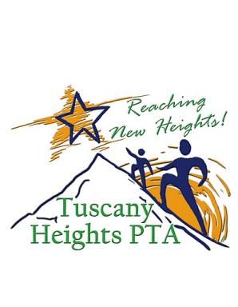

Tiger Directory
Art Contest
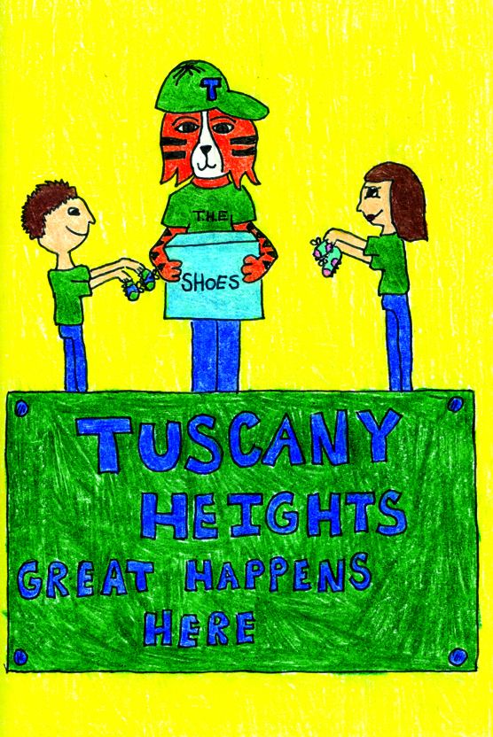
Calling all Tiger Artists…
Your artwork could be featured in the
2016-17 Tuscany Heights Online Directory
Contest Requirements:

- All drawings should be submitted on 5 ½ x 8 ½ inch white paper (½ sheet)
- Artwork should be drawn vertically on the paper
- Students may use markers, pens, pencils, and crayons; however, if they use pencils, make sure that it is dark enough to copy
- Theme: “Earning our stripes one habit at a time!”
- First and last name, evening phone #, teacher, and grade PRINTED on the back of the artwork with parent signature to give consent to participate
- The artwork will appear online in color. Make it bold!
- All entrants will receive a special Art Spirit Stick
- Must be submitted to the front office no later than Friday, September 9, 2016

Winners will be selected by the Tuscany Heights PTA Board and notified in October. E-mail any questions to directoryartcontest@tuscanyheightspta.org. Trophies will be awarded!
PARENT SIGNATURE ON BACK OF ARTWORK IS MANDATORY
tuscanyheightspta.org

