North East Independent School District
210-407-0040 – 8961 Tesoro Drive – San Antonio, Texas 78217

Brian G. Gottardy, Ed.D.
Superintendent of Schools

April 23, 2014

Dear NEISD Community:

I want to thank you for your patience and cooperation during this uncertain time. As you know, the San Antonio Police Department has been investigating claims that there would be violence at an unidentified elementary school in the city on Thursday, April 24. While police have said this threat is not considered credible, we continue to stay on high alert and are taking the situation seriously.

Due to extra precautionary measures being taken, events during the school day tomorrow will be modified or canceled at elementary schools. We will limit the number of visitors to all NEISD campuses. Our schools will be considered “closed campuses.”

In addition, we will have a police presence at every one of our schools, and administrators, teachers and staff are working together to ensure the safety of our students, staff and community.

I appreciate your continued support.

Sincerely,
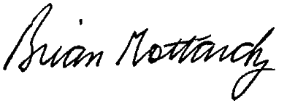

Brian Gottardy, Ed.D.
Superintendent of Schools

