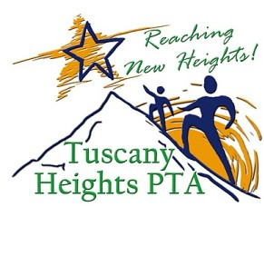
Red Ribbon Week
“Be the Best Me”
October 22nd-26th

The aim of this week is to help educate students of the benefits of healthy lifestyles and making the best choices. Please join Tuscany Heights in celebrating Red Ribbon Week by participating in our planned activities.

Monday - Red Ribbon Week Launch
Reagan High School Winner’s Circle morning greetings.
Wear Red

Tuesday - Team Up to Be the Best
Bring uniforms for our sister school all week (see details in eblast).
Wear favorite team jersey or team colors

Wednesday – Be Your Silly Self
Anti-bullying Magician John O’Bryant performs "Friends Not Foes Magic Show" .
Wear crazy socks, tie, hats, etc.

Thursday - Turn Your Back on Bullies
Wear shirt backwards or inside out

Friday - Show Tuscany Pride
Tusky will award students who are “Being the Best Me” with spirit sticks today.
Wear Tuscany shirts

www.tuscanyheightspta.org

