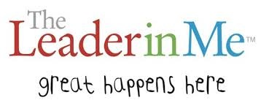
We want to recognize our students who “Sharpen the Saw” by helping out in our community. Any community volunteer service that occurred between May 2014 and April 2015 qualifies. There are TWO levels of community volunteer service for which students can be recognized.

Level 1 - Community Service Spirit Stick
Students that record 10-25 hours of volunteer service will receive a "community service" spirit stick. Service hours must be logged in the student's "Leader in Me" service log (copy on reverse side). Service logs will be collected by teachers on April 17th, 2015.
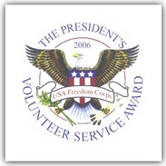

Level 2 - President’s Volunteer Service Award
THE PTA will once again be giving the President's Volunteer Service Award (PVSA). Students aged 5-10 years old that record 26 or more hours and students aged 11-13 years old that record 50 or more hours will be eligible to attend a special reception and receive their official President’s Volunteer Service Award pin. Since this is a government sponsored program, no handwritten service logs can be accepted. Service hours must be logged on the PVSA website by April 17, 2015. Use the following link to get instructions regarding logging hours on the website. Please note that a different email address must be used for each child when setting up and accessing your PVSA account.

www.tuscanyheightspta.org/presidential-volunteer-service-award

