LIGHTING THE WAY TO LEADERSHIP!

Tuscany Heights 5th Annual

**GREENBACK** Fundraiser

Help RAISE **$10,000**

for our school programs and our principals will be lighting up the stage singing a song chosen by the students!

**If we can raise $2,000 with this round of donations, Dell will give us a contribution of $3,000!!**

Our goals:

**$2,500 –** Tusky will be lighting up the announcements doing a dance to “Lights” by Ellie Goulding.

**$7,500** – Pajama Day! Students can wear their pajamas and bring a flashlight for special reading time in class. Don’t forget to wear your spirit shirt with your pajama pants!

**$10,000** – Lighting Up the Stage!!

Mrs. Bailey and Mrs. Hayden will be performing a song chosen by the students in front of the entire student body!

Greenbacks



**What are Greenbacks?**

A tax-deductible contribution to the Tuscany Heights Elementary PTA. Your dollars support programs like FIELD TRIPS (parents are not asked to pay for any field trips!), Bike Rodeo, student enrichment, Arts in Education, Grandparent’s Day, Author Visits, etc. ALL MONEY GOES TO THE SCHOOL AND STUDENTS!

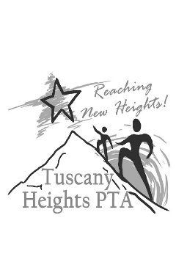

**WHY?**

* Our Greenback goal is $10,000
* **100%** of proceeds go to benefit students.
* Great way to help your school.
* NO CATALOG or FOOD SALES
* Only other major fundraiser is Run for the Heights on **2/28/15**.

**HOW?**

Make a cash, check (payable to T.H.E. PTA), or online donation at **tuscanyheightspta.org** (credit card or PayPal). Don’t forget to see if your company or corporation has contribution matching!

Let’s **LIGHT THE WAY TO LEADERSHIP**

and make our principals LIGHT UP the stage and belt out a song at

TUSCANY HEIGHTS ELEMENTARY!