Tuscanyheightspta.org
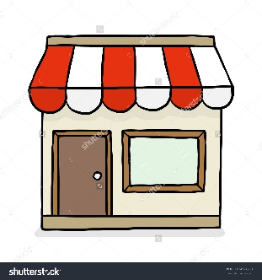
IT’S BOX TOP SHOP TIME

Dates: Monday, February 13-Friday, February 17
Where: Tuscany Heights Rotunda
Time: Before School
Bring in your Box Tops (be sure to check expiration dates)
Neatly cut Box Tops. Attach them to this sheet (tape or glue stick work perfectly)
OR neatly cut Box Tops and place them in a Ziploc bag (bags of 50 pre-counted Box Tops are greatly appreciated).
Box Top Shop items will be priced in increments of: 25 Box Tops, 50 Box Tops, and 100 Box Tops
LOTS of GREAT items like scented mechanical pencils, NFL items, jewelry, decoder spy pens and MORE, come check it out! Supplies are limited so shop early!
HEB Box Top promotion begins
February 8
Purchase 15 Box Top items (in one trip) and earn
100 BONUS BOX TOPS
Purchase 10 Box Top items (in one trip) and earn
60 BONUS BOX TOPS

