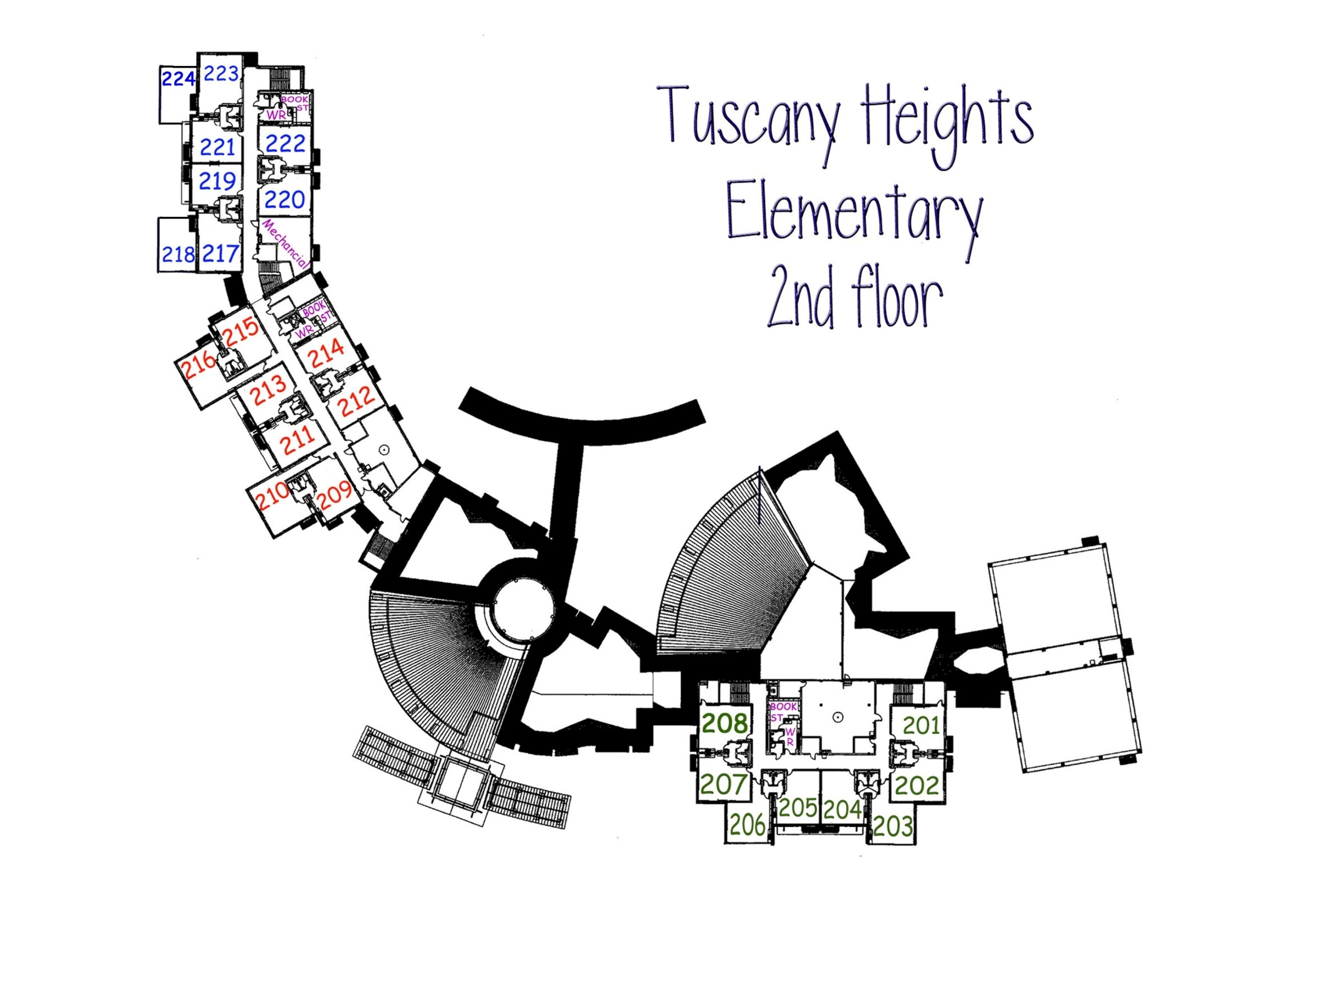

3rd Grade

224 Kramer

223 Ferguson

222 Open

221 Herrera

220 Ryan

219 Fonger

218 Anderson

217 Drake

4th Grade

216 Open

215 Open

214 Cue

213 Valdez

212 Forsyth

211 Cowan

210 Morris

209 Luna

Holeman (Speech)

*

*

**5th Grade**

208 Blackler

207 Schlosser

206 Johle

205 Davis

204 Open

203 Rodriguez

202 Morrow

201 Hesles