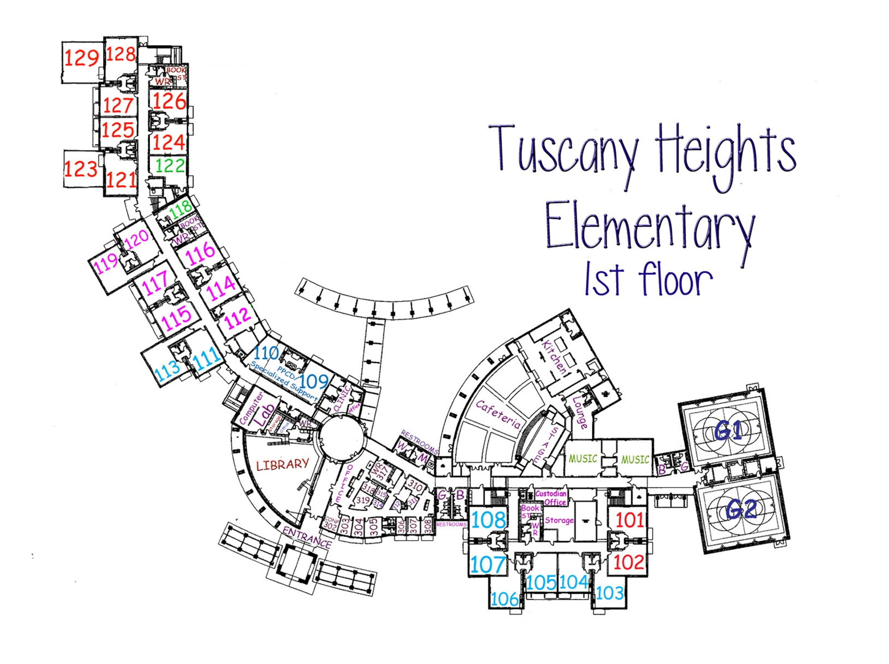

2nd Grade

129 Silvers

128 Branch

127 Open

126 Guintini

125 Balcar

124 Grams

123 Pantuso

121 Fontenot

113 SmartBoard Lab

111 GT

109 Motor Lab

110 Johnson, Jette

112 Special Ed Office (Fernandez, Welch, Murray, Blackmon)

122 Open

118 Fewell

101 Art

102 Academic Motor Lab

**KINDER**

108 Cervenka

107 Shelby

106 Young

105 Chapman

104 RTI Room

103 Drew

102

Brown

Neibel

**1st Grade**

120 Borgeson

119 Helms

117 Lunsford

116 Hunt

115 Schmid

114 Jayson

P.E.

G1-Fields

G2-Burges